Resource Allocation in Heterogeneous Architectures

**Mid-Term Report**

THESIS NAME：MID-TERM DEFENSE FOR MASTER’S DEGREE

STUDENT NAME：MUHAMMAD (哈马德) ABUBAKAR SADDIQ SPECIALTY：COMPUTER SYSTEMS ARCHITECTURE

STUDENT NUMBER：LS1806202

SUPERVISOR：PROF. RUI WANG

DATE：09/12/2020

**School of Computer Sciences and Engineering**

**Beihang University, Beijing, China**

**GPU Report:**

A **graphics processing unit** (**GPU**) is a specialized [electronic circuit](https://en.wikipedia.org/wiki/Electronic_circuit) designed to rapidly manipulate and alter [memory](https://en.wikipedia.org/wiki/Memory_(computing)) to accelerate the creation of [images](https://en.wikipedia.org/wiki/Digital_image) in a [frame buffer](https://en.wikipedia.org/wiki/Frame_buffer) intended for output to a [display device](https://en.wikipedia.org/wiki/Display_device). GPUs are used in [embedded systems](https://en.wikipedia.org/wiki/Embedded_system), [mobile phones](https://en.wikipedia.org/wiki/Mobile_phone), [personal computers](https://en.wikipedia.org/wiki/Personal_computer), [workstations](https://en.wikipedia.org/wiki/Workstation), and [game consoles](https://en.wikipedia.org/wiki/Game_console).

Modern GPUs are very efficient at manipulating [computer graphics](https://en.wikipedia.org/wiki/Computer_graphics) and [image processing](https://en.wikipedia.org/wiki/Image_processing). Their highly [parallel structure](https://en.wikipedia.org/wiki/Parallel_computing) makes them more efficient than general-purpose [central processing units](https://en.wikipedia.org/wiki/Central_processing_unit) (CPUs) for [algorithms](https://en.wikipedia.org/wiki/Algorithm) that process large blocks of data in parallel. In a personal computer, a GPU can be present on a [video card](https://en.wikipedia.org/wiki/Video_card) or embedded on the [motherboard](https://en.wikipedia.org/wiki/Motherboard). In certain CPUs, they are embedded on the CPU [die](https://en.wikipedia.org/wiki/Die_(integrated_circuit)).[[1]](https://en.wikipedia.org/wiki/Graphics_processing_unit#cite_note-1)

In the 1970s, the term "GPU" originally stood for *graphics processor unit* and described a programmable processing unit independently working from the CPU and responsible for graphics manipulation and output.[[2]](https://en.wikipedia.org/wiki/Graphics_processing_unit#cite_note-2)[[3]](https://en.wikipedia.org/wiki/Graphics_processing_unit#cite_note-3) Later, in 1994, [Sony](https://en.wikipedia.org/wiki/Sony) used the term (now standing for *graphics processing unit*) in reference to the [PlayStation](https://en.wikipedia.org/wiki/PlayStation_(console)) console's [Toshiba](https://en.wikipedia.org/wiki/Toshiba)-designed [Sony GPU](https://en.wikipedia.org/wiki/PlayStation_technical_specifications#Graphics_processing_unit_(GPU)) in 1994.[[4]](https://en.wikipedia.org/wiki/Graphics_processing_unit#cite_note-gpu-4) The term was popularized by [Nvidia](https://en.wikipedia.org/wiki/Nvidia) in 1999, who marketed the [GeForce 256](https://en.wikipedia.org/wiki/GeForce_256) as "the world's first GPU".[[5]](https://en.wikipedia.org/wiki/Graphics_processing_unit#cite_note-5) It was presented as a "single-chip [processor](https://en.wikipedia.org/wiki/Processor_(computing)) with integrated [transform, lighting, triangle setup/clipping](https://en.wikipedia.org/wiki/Transform,_clipping,_and_lighting), and rendering engines".[[6]](https://en.wikipedia.org/wiki/Graphics_processing_unit#cite_note-6) Rival [ATI Technologies](https://en.wikipedia.org/wiki/ATI_Technologies) coined the term "**visual processing unit**" or **VPU** with the release of the [Radeon 9700](https://en.wikipedia.org/wiki/R300) in 2002.[[7]](https://en.wikipedia.org/wiki/Graphics_processing_unit#cite_note-7)

**GPU Analysis of the dataset:**

When we analysis that the GPU of DisplayPort_Connection and ROPs Than the result is:

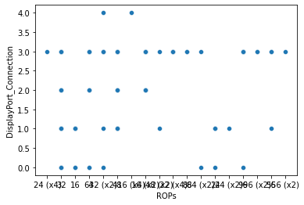

**Compare the Process and the Pixals Rate:**

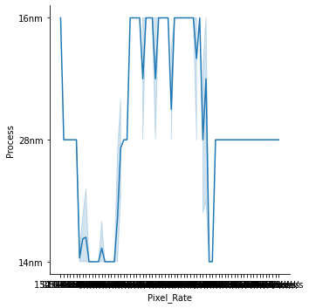

**Compare the Pixel Rate and Best Resolution:**

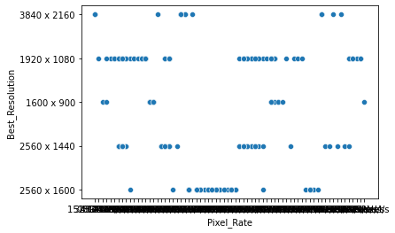

**Compare All the data which is used in the GPU:**

